

Mehran University of Engineering and Technology Jamshoro

**ASSIGNMENT : LAB 1**

**SUBJECT : PROGRAMMING FUNDAMENTALS**

**ROLL NO : 24BSAI29**

**SUBMITTED BY : SYED MUHAMMAD QASIM**

**SUBMITTED TO : MA’AM FAHAMA BARKZAI**

**INSTALLATION OF AN IDE FOR C++ PROGRAMMING:**

**Step 1: Choose an IDE**

There are several popular Integrated Development Environments (IDEs) for C++

development. Some commonly used ones are:

1. Code::Blocks
2. Visual studio Code
3. Dev-C++

For this guide, I will focus on installing VS Code as it is lightweight, beginner-friendly, and widely used for C++ development.

**INSTALLATION OF VISUAL STUDIO CODE (VS CODE) FOR C++ PROGRAMMING**

**Step 01: Download VS Code**

* Go to the official website for Visual Studio Code:

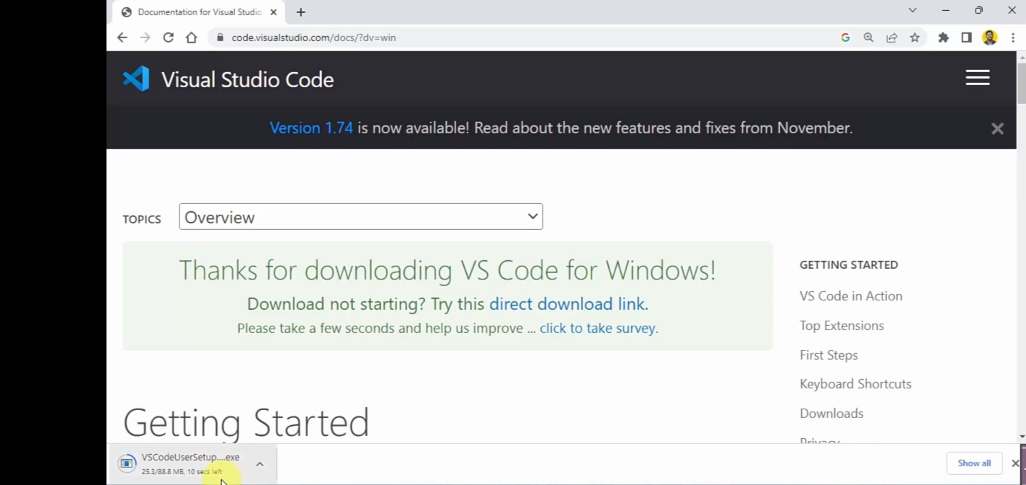

**Step 2: Install VS Code.**

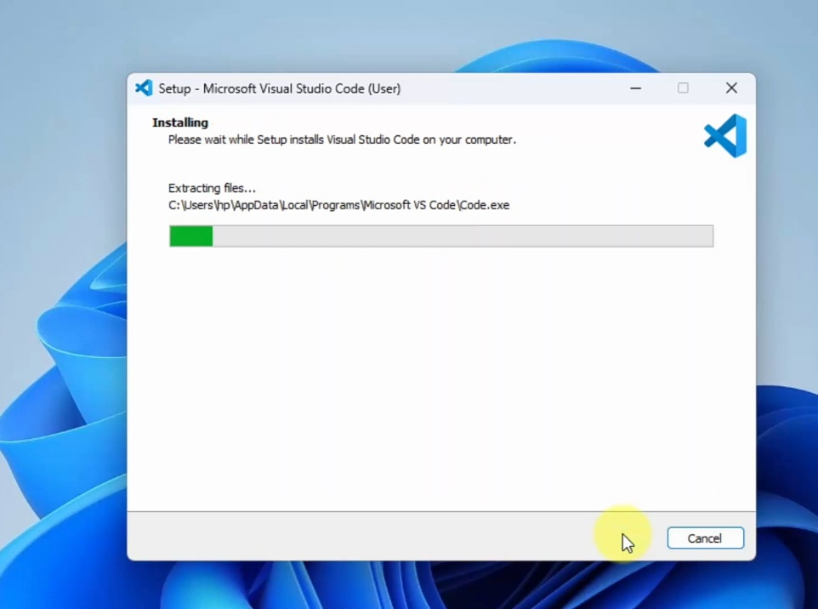

**Step 3: Complete the installation by clicking finish.**

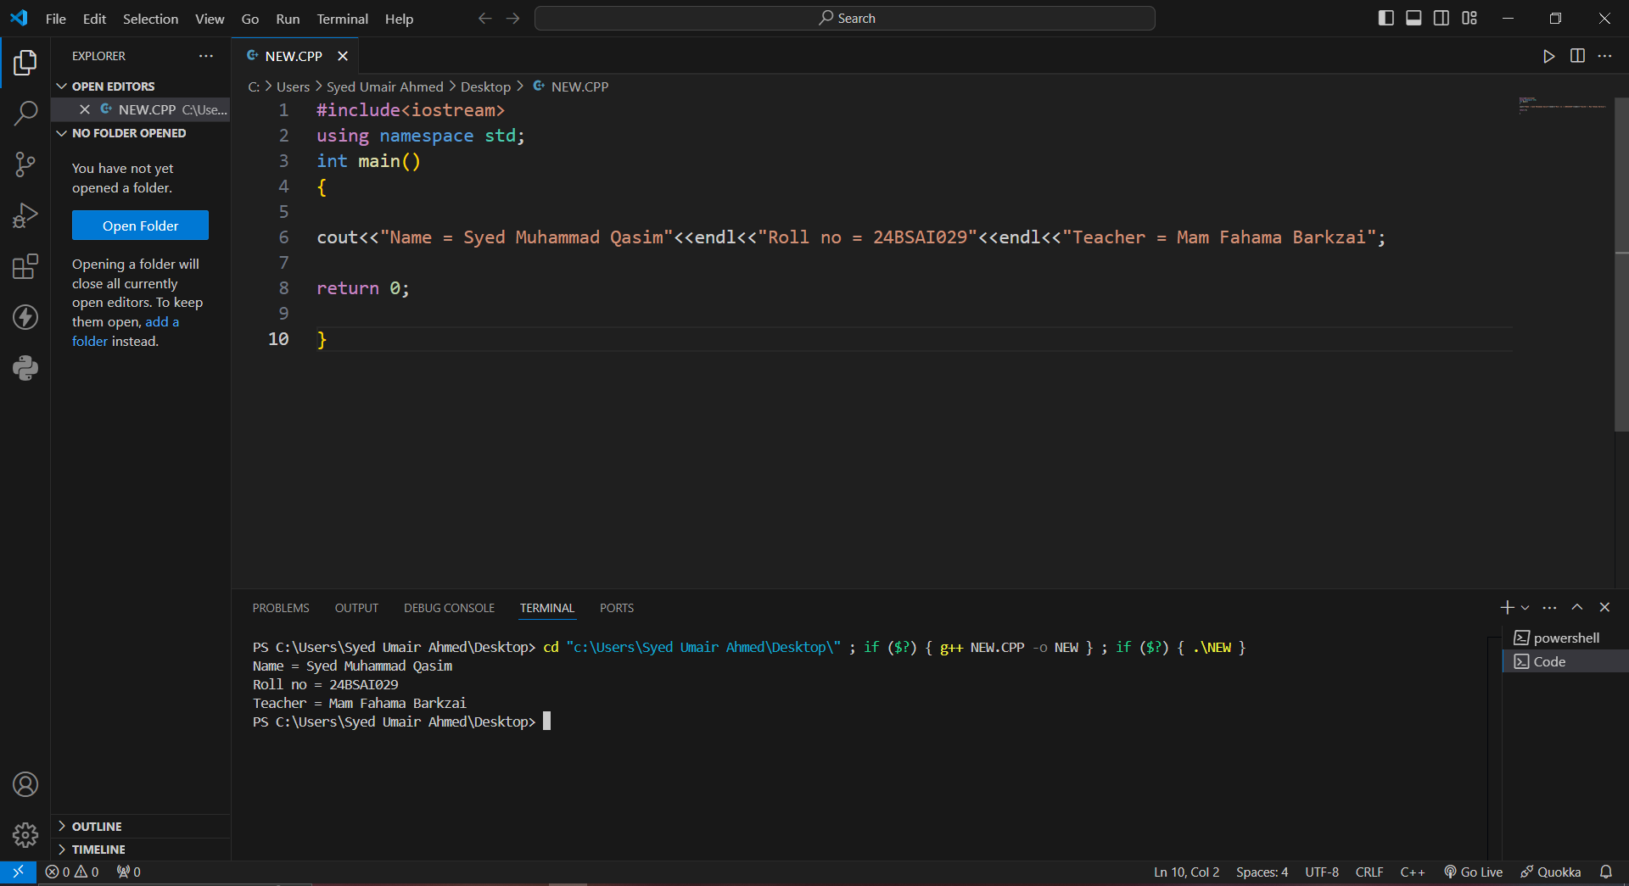**USE OF “endl” IN A C++ PROGRAMING:**

Here is the output for the above C++ program .It takes input from the user, including the name, roll number, and teacher’s name, and then displays the entered information back to the user.

This is the end of the assignment. The program works and shows how the endl function in C++ not only adds a newline to the output but also flushes the output buffer to ensure immediate display. This ensures that the output is formatted correctly and visible right away.